**Hip Exoskeleton Motion Assistance**

Hung-Ta Lai1, En-Yu Shen1, Yun-Ting Liu1, An-Yu Huang1 and You-Yin Chen1*

1 Department of Biomedical Engineering, National Yang Ming Chiao Tung University, Taipei, Taiwan.

[youyin.chen@nycu.edu.com](mailto:youyin.chen@nycu.edu.com)

**INTRODUCTION**

Prolonged physical activities lead to muscle fatigue and pose safety and health risks when moving. Our system aims to reduce the intensity of specific muscle usage and extend the duration of strenuous activities when needed by duty officers in disaster relief sites, where heavy lifting is required [1]. In this study, we integrated multiple Electromyography (EMG) patches with the exoskeleton, monitoring joint angles, Inertial measurement unit (IMU), and displaying the muscle status in real-time on the augmented reality (AR) interface. A reinforcement learning (RL) model is used to adapt to the user's gait, aiming to alleviate the burden on specific muscles [2, 3].

**METHODS**

We employ the Distributed Deep Deterministic Policy Gradient (D4PG) as our primary strategy for predicting thigh gait [4]. Given the personalized characteristics of EMG signals obtained from the EMG dongle, we have chosen a Deep Learning (DL) architecture, surpassing the performance of traditional dynamics models [5, 6]. This approach aims to overcome the traditional dynamics models encounter when handling rapid motion transitions. The Temporal Convolutional Network (TCN) within the agent framework is utilized for time series discovery, while the Deep Q-Network (DQN) is used to optimize the actions. By utilizing a data-driven method, our system can adapt to real-time and rapidly changing scenarios. The Gait Pattern function translates the TCN outputs into physical meanings, such as muscle states, cadence, and gait, and the duration buffer manages the states of the inputs. Through three sections comparing integrated EMG (iEMG) with assistance and without assistance, we tested the hypothesis that learning directly from data enables flexible adaptation to swift motion changes and offers more precise control to reduce the burden of Rectus Femoris, Biceps Femoris muscles when walking(**Figure 1**).

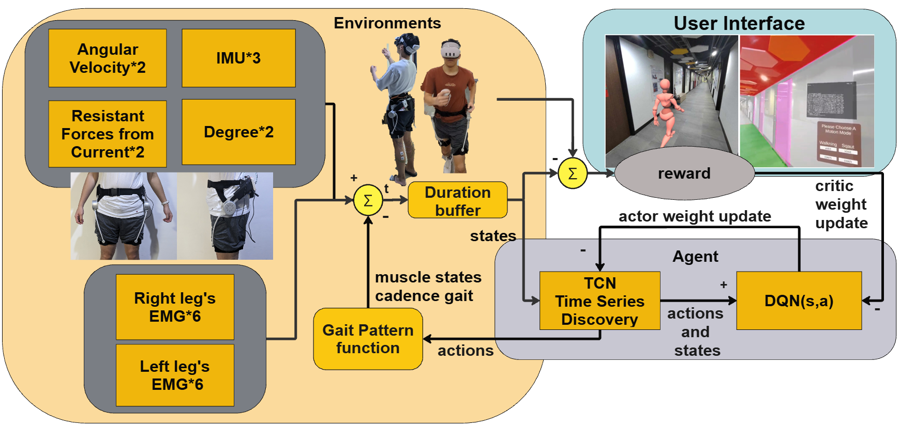

**Figure 1. the flowchart of the algorithm.** The EMG and data from the exoskeleton interact with the environment through the agent, optimizing two models based on rewards.

**RESULTS AND DISCUSSION**

Through iterative updates of the DL model weights, the TCN generates advantageous actions for Gait Patterns under the guidance of personalized reward functions. These reward functions monitor discrepancies in the user's specific gait pattern templates and detect fatigue levels. **Figure 2** illustrates model training results while the user is walking with the exoskeleton. The exoskeleton effectively reduces the intensity of specific muscle activities by predicting the next gait patterns for subsequent movements. This training process highlights the system's adaptability, allowing for optimization by acquiring new weight sets by interacting with the exoskeleton without necessitating mathematical modifications to the existing model [5, 6].

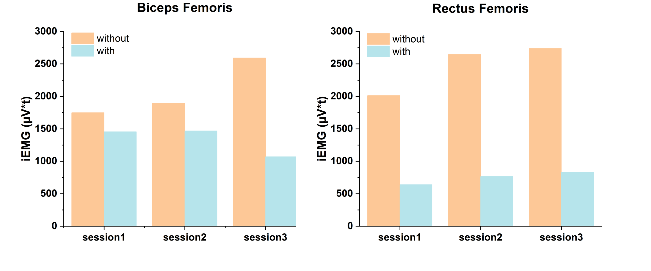

**Figure 2. Rectus femoris and biceps femoris iEMG.** The iEMG values for the Rectus Femoris and Biceps Femoris muscles across three tests. The comparisons are made between conditions w. exoskeleton assistance (blue bars) and w.o. exoskeleton assistance (orange bars).

**CONCLUSIONS**

Our system employed RL and a real-time AR interface to optimize gait and reduce muscle fatigue, specifically targeting disaster relief workers. This approach enhances flexibility and effectiveness compared to traditional exoskeletons, extending the duration of physical activity and mitigating associated health risks.

**REFERENCE**

[1] Wan, J.-j., et al., *Muscle fatigue: general understanding and treatment.* Experimental & molecular medicine, 2017. **49**(10): p. e384-e384.

[2] Yuan, Y., et al., *DMP-based motion generation for a walking exoskeleton robot using reinforcement learning.* IEEE Transactions on Industrial Electronics, 2019. **67**(5): p. 3830-3839.

[3] Kang, I., P. Kunapuli, and A.J. Young, *Real-time neural network-based gait phase estimation using a robotic hip exoskeleton.* IEEE Transactions on Medical Robotics and Bionics, 2019. **2**(1): p. 28-37.

[4] Guo, Y., et al., *DDPG-based controlling algorithm for upper limb prosthetic shoulder joint.* International Journal of Control, 2024. **97**(5): p. 1083-1093.

[5] Huang, R., et al. *Hierarchical interactive learning for a human-powered augmentation lower exoskeleton*. in *2016 IEEE international conference on robotics and automation (ICRA)*. 2016. IEEE.

[6] Chen, S., et al., *Precision interaction force control of an underactuated hydraulic stance leg exoskeleton considering the constraint from the wearer.* Machines, 2021. **9**(5): p. 96